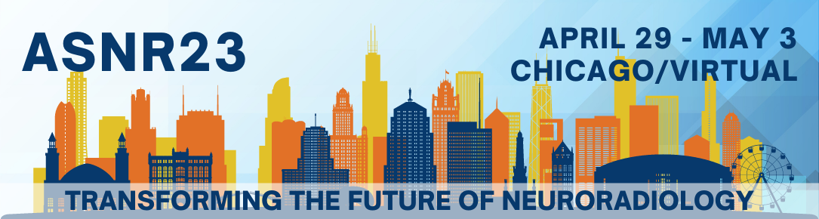
Date

First and Last Name
Institution
Address
City, State/Province, Zip/Country Code
Country

Dear First and Last Name,

On behalf of the American Society of Neuroradiology (ASNR), I am pleased to invite you to attend the 61st Annual Meeting of the American Society of Neuroradiology to be held April 29 – May 3, 2023, at the Sheraton Grand Chicago Hotel in Chicago, IL, USA.

Given the rapidly changing environment we find ourselves working in, it seems fitting that the theme for the 2023 Annual Meeting is Transforming the Future of Neuroradiology. This international gathering will showcase and educate members on the many new and exciting directions our field is moving, from advances in research to educational and practice innovations.

ASNR23 provides attendees the opportunity to learn the most up-to-date, best practices in neuroradiology through invited lectures, oral and electronic research presentations, and exhibits. Other planned topics include novel training methods, shifting paradigms in career paths, and exploring new treatment systems.

Please note that ASNR attendees are responsible for travel expenses that include airfare, ground transportation, hotel, meals, and travel insurance. This letter serves as an invitation to register for the meeting and as a document to aid in the visa application process.

Additional information about the meeting is available on the ASNR Annual Meeting page.

We hope to see you in Chicago!

Sincerely,
ASNR Meetings Department

